**Project Planning Phase**

|  |  |
| --- | --- |
| Date | 14 November 2022 |
| Team ID | PNT2022TMID06176 |
| Project Name | Gas Leakage monitoring & Alerting system for Industries |
| Maximum Marks | 8 Marks |

**Product Backlog, Sprint Schedule, and Estimation (4 Marks)**

|  |  |  |  |  |  |  |
| --- | --- | --- | --- | --- | --- | --- |
| **Sprint** | **Functional Requirement (Epic)** | **User Story**  **Number** | **User Story / Task** | **Story Points** | **Priority** | **Team Members** |
| Sprint-1 | Registration | USN-1 | As a user, I can register for the application by entering my email, password, and confirming my password. | 10 | HIGH | VISHNU V |
| Sprint-1 |  | USN-2 | As a user, I will receive confirmation email once I have registered for the application | 10 | HIGH | GUNASEELAN D |
| Sprint-1 | Login | USN-3 | As a user, I can log into the application by entering email & password | 10 | HIGH | SANJAI S |
| Sprint-2 | Input details | USN-4 | As a user, I can set the threshold value | 10 | MEDIUM | MANOJ KUMAR S |
| Sprint-2 | safety alert prediction-1 (small gas content) | USN-5 | As a user, I should get the indication through a red LED and a message should be sent.. | 20 | HIGH | VISHNU V |
| sprint -3 | safety alert prediction-2(high gas content) | USN-6 | As a user, I should get message alert and alarm should get ON | 20 | HIGH | GUNASEELAN D |
| sprint- 3 | sensor value < threshold value | USN-7 | As a user, I should get an indication through green LED. | 10 | HIGH | SANJAI S |
| sprint -4 | repeat the process for maintaining strict safety | USN - 8 | As a user i can expect that the process should repeat once i give supply to the device for more security. | 20 | HIGH | MANOJ KUMAR S |

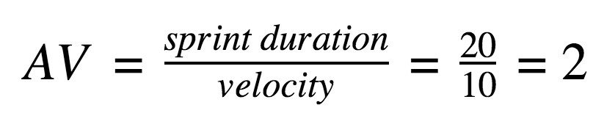**Project Tracker, Velocity & Burndown Chart: (4 Marks)**

|  |  |  |  |  |  |  |
| --- | --- | --- | --- | --- | --- | --- |
| **Sprint** | **Total Story Points** | **Duration** | **Sprint Start Date** | **Sprint End Date (Planned)** | **Story Points**  **Completed (as on**  **Planned End Date)** | **Sprint Release Date (Actual)** |
| Sprint-1 | 30 | 7 Days | 1 NOV 2022 | 7 NOV2022 |  |  |
| Sprint-2 | 30 | 5 Days | 8 NOV 2022 | 12 NOV 2022 |  |  |
| Sprint-3 | 30 | 3 Days | 13 NOV 2022 | 15 NOV 2022 |  |  |
| Sprint-4 | 20 | 4 Days | 16 NOV 2022 | 19 NOV 2022 |  |  |
|  |  |  |  |  |  |  |
|  |  |  |  |  |  |  |
|  |  |  |  |  |  |  |
|  |  |  |  |  |  |  |

**Velocity:**

Imagine we have a 10-day sprint duration, and the velocity of the team is 20 (points per sprint). Let’s calculate the team’s average velocity (AV) per iteration unit (story points per day)

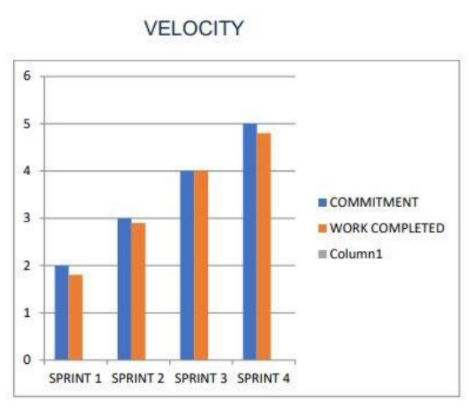

**Burndown Chart:**

